2017 – Maharashtra – Pink Bollworm
Source: Times of India
Date: 2017
Crop: Cotton
Pest: Pink bollworm
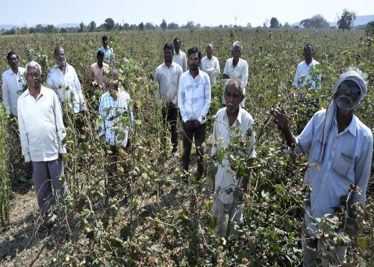
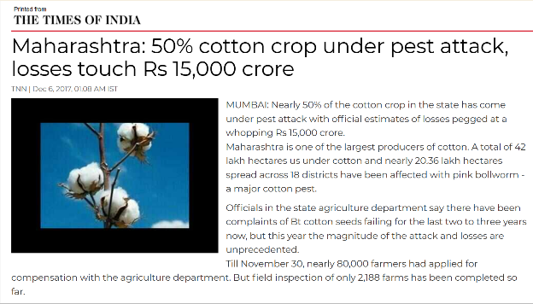
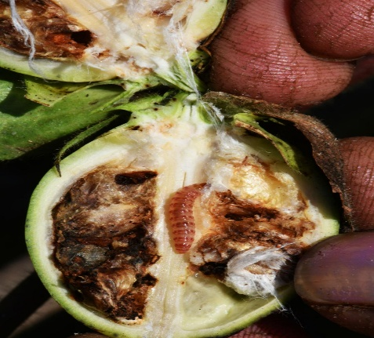
Brief Description
In 2017, Maharashtra experienced a severe outbreak of pink bollworm in cotton crops. According to the report, approximately 20.36 lakh hectares across 18 districts were affected, with estimated losses of around ₹15,000 crore. The infestation caused serious damage to cotton bolls and affected both yield and cotton quality.

Root Cause
The major contributing factors identified were pest resistance and ineffective protection of cotton bolls.

Effect on Crops
- Damage to cotton bolls
- Reduction in cotton yield
- Deterioration of cotton quality

Effect on Farmers
Farmers experienced major financial losses and had to spend more on pest-management activities.

Government Action
Authorities carried out damage assessment and implemented pest-management measures and farmer-support activities. However, the problem continued in subsequent years.

Was the Problem Resolved?
Not completely. Pink bollworm continued to affect cotton crops in later years
News link: https://timesofindia.indiatimes.com/city/mumbai/50-cotton-crop-under-pest-attack-losses-touch-rs-15000cr/articleshow/61938522.cms?utm
2018 – Karnataka – Fall Armyworm
Source: EPPO / agricultural scientific records
Year: 2018
Crop: Maize
Pest: Fall Armyworm (Spodoptera frugiperda)
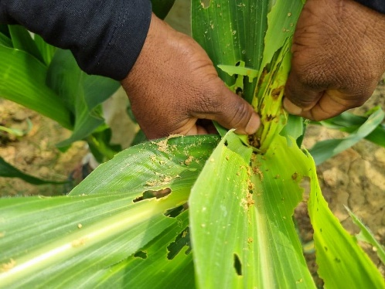
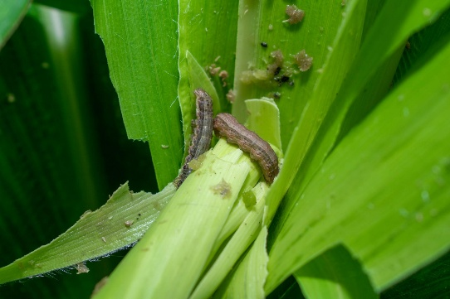
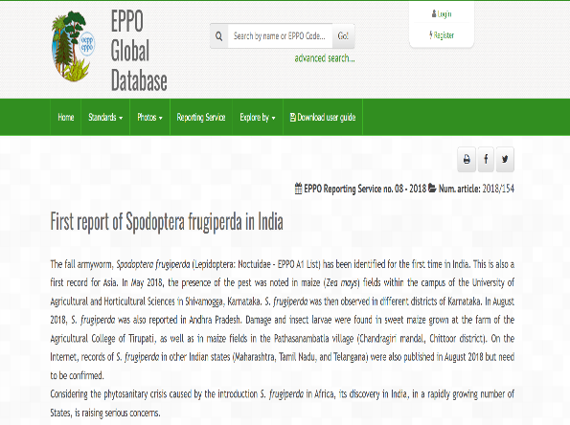

Brief Description
Fall Armyworm was reported in India in 2018, with Karnataka among the first states where its presence was documented. The invasive pest rapidly became a serious threat to maize cultivation because of its high reproductive and migratory capacity.

Root Cause
The major cause was the introduction of Fall Armyworm into India, followed by rapid reproduction and migration.

Effect on Crops
- Severe feeding damage to maize leaves
- Damage to growing points
- Reduced crop growth and productivity

Effect on Farmers
Farmers faced yield losses, increased pesticide expenditure and additional field-monitoring requirements.

Government/Scientific Action
Authorities focused on:
- Pest surveillance
- Pest identification
- Farmer awareness
- Integrated pest management

Was the Problem Resolved?
No. Fall Armyworm became an established pest in India
News Link: https://gd.eppo.int/reporting/article-6348?utm

2019–20 – Rajasthan/Gujarat – Desert Locust
Source: Press Information Bureau, Government of India
Date: 27 May 2020
Pest: Desert locust
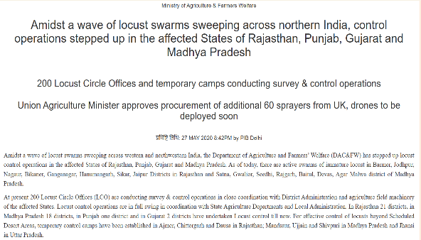
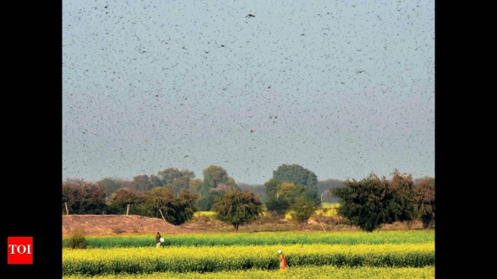
.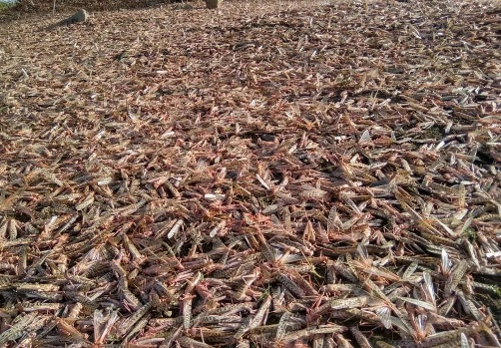

Brief Description
During 2019–20, large desert locust swarms threatened agricultural crops in several parts of India. Government agencies monitored and surveyed locust populations and carried out control operations in affected regions.

Root Cause
Favourable weather, breeding conditions and migration supported the development and movement of locust populations.

Effect on Crops
- Rapid destruction of vegetation
- Consumption of standing crops
- Large-scale crop damage

Effect on Farmers
Farmers faced crop losses and increased expenditure for pest-control operations.

Government Action
The response included:
- Locust surveillance
- Field surveys
- Pesticide spraying
- Specialised locust-control teams
- Central–state coordination

Was the Problem Resolved?
Immediate outbreaks were controlled, but locusts remain a recurring agricultural threat.
News Link: https://www.pib.gov.in/PressReleasePage.aspx?PRID=1627276&utm
2020 – India – Major Desert Locust Outbreak
Source: TIME
Date: 2 June 2020
Locations: Rajasthan, Uttar Pradesh, Madhya Pradesh, Maharashtra, Gujarat and others.

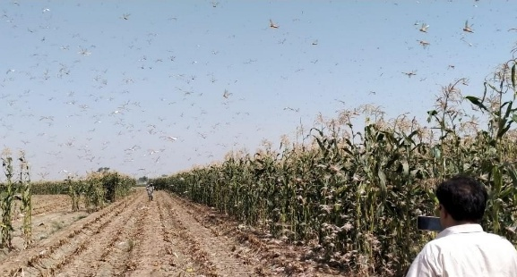
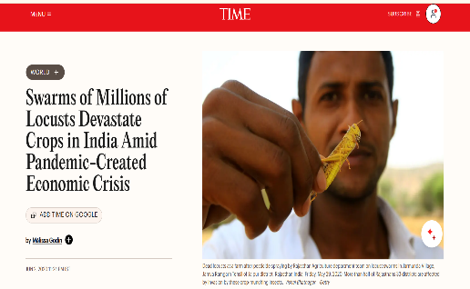
The report described one of India's worst locust outbreaks in decades. Locust swarms entered Rajasthan from Pakistan and subsequently moved into several Indian states.

Brief Description
In 2020, India experienced one of its most serious locust outbreaks in decades. Swarms entered Rajasthan from Pakistan and subsequently moved into several Indian states. Their rapid movement posed a major threat to standing agricultural crops.

Root Cause
The outbreak was associated with favourable conditions that supported locust breeding, multiplication and migration.

Effect on Crops
The swarms consumed vegetation and destroyed standing crops.

Effect on Farmers
Farmers faced the possibility of large-scale agricultural losses.

Government Action
Reported control measures included:
- Drones
- Fire trucks
- Pesticide spraying
- Farmer alerts

Was the Problem Resolved?
The immediate infestation was controlled, but the risk of future locust outbreaks remained.
News Link: https://time.com/5846539/india-locust-pandemic/?utm
2023 – Punjab – Paddy Dwarfing Disease
Source: Punjab Agricultural University
Year: 2023
Crop: Paddy
Disease: Southern Rice Black-Streaked Dwarf Virus (SRBSDV)
PAU reported that the mysterious dwarfing disease had appeared in the North Indian rice-growing region during the 2022 Kharif season and that scientists subsequently identified SRBSDV as the cause.
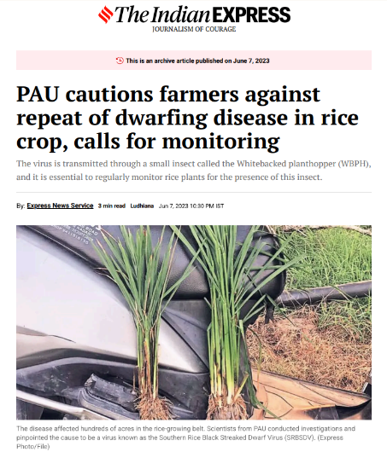
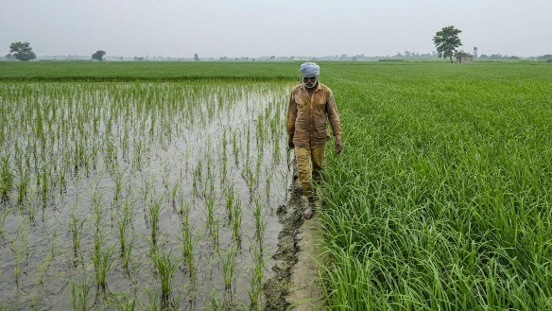
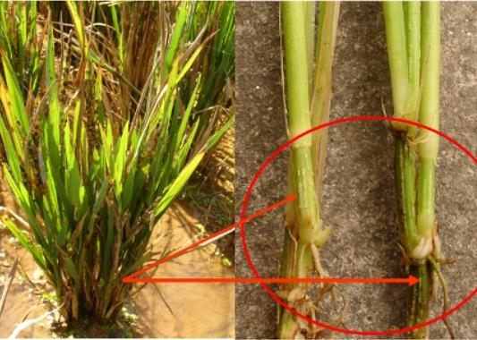

Brief Description
A mysterious dwarfing disease was observed in the North Indian rice-growing region during the 2022 Kharif season. Scientific investigations subsequently identified Southern Rice Black-Streaked Dwarf Virus (SRBSDV) as the cause.

Root Cause
The disease is a viral infection transmitted by an insect vector.

Effect on Crops
- Plant stunting
- Reduced tillering
- Reduced yield

Effect on Farmers
Farmers experienced crop damage and additional management expenses.

Scientific/Government Action
Actions included:
- Disease investigation
- Vector monitoring
- Farmer advisories
- Development of disease-management strategies

Was the Problem Resolved?
No.The disease subsequently reappeared.
News Link: https://pau.edu/index.php?DO=viewEventDetail&_act=manageEvent&intID=7672&utm
2025 – Punjab/Haryana/Rajasthan – Green Leafhopper
Source: Times of India
Date: 3 August 2025
Crop: Cotton
Pest: Green leafhopper/Jassid
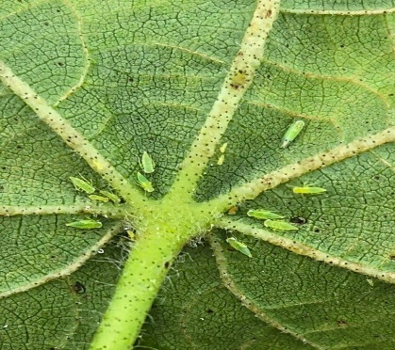
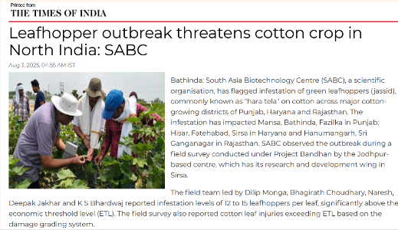
A field survey found 12–15 leafhoppers per leaf, above the Economic Threshold Level. The infestation affected cotton-growing areas in Punjab, Haryana and Rajasthan.
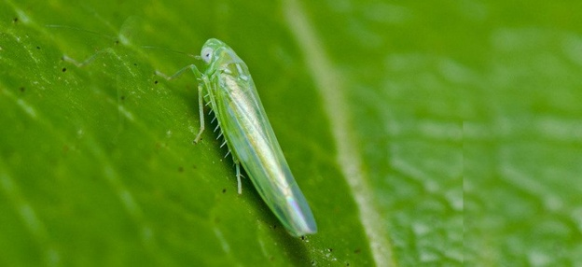

Brief Description
In 2025, green leafhopper or jassid infestation was reported across cotton-growing areas of Punjab, Haryana and Rajasthan. A field survey recorded 12–15 leafhoppers per leaf, which was above the Economic Threshold Level.

Root Cause
High rainfall, humidity and persistent cloud cover created favourable conditions for the pest.

Effect on Crops
The infestation caused:
- Yellowing
- Leaf curling
- Browning
- Drying
- Reduced photosynthesis
- Potential yield loss

Effect on Farmers
Farmers faced potential yield losses and increased pest-control expenses.
Government/Scientific Action:
Agricultural authorities and experts recommended regular field monitoring, accurate identification of the pest, assessment of infestation levels and timely pest-control measures. Pest surveillance and agricultural advisories were used to help farmers respond when pest populations crossed recommended thresholds.
Resolved?
Not completely. Continued monitoring was required because the infestation remained a threat to cotton crops.
News Link: https://timesofindia.indiatimes.com/city/chandigarh/leafhopper-outbreak-threatens-cotton-crop-in-region/articleshow/123028625.cms?utm

2025 – Punjab – Paddy Dwarf Virus
Source: Hindustan Times
Crop: Paddy
Disease: SRBSDV
Date: 2025
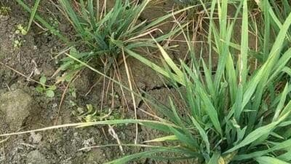
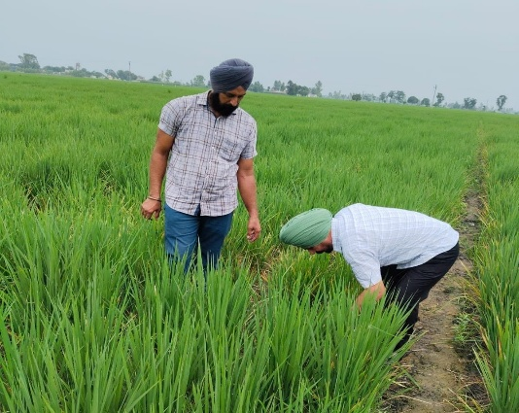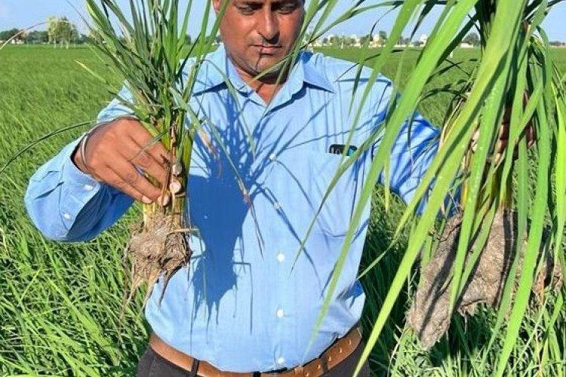

Brief Description
In 2025, SRBSDV again affected paddy crops in Punjab. Farmers reported significant damage, with one farmer reporting that 20 of his 60 acres had been affected.

Root Cause
The virus is transmitted by the white-backed planthopper.

Effect on Crops
- Stunted plants
- Poor crop development
- Reduced yield

Effect on Farmers
Farmers experienced crop losses and additional cultivation/re-sowing expenses.

Government/Scientific Action
Authorities recommended field monitoring, identification of infected plants and farmer advisories.

Was the Problem Resolved?
No. The recurrence of the disease demonstrates the need for continuous monitori
News Link: https://timesofindia.indiatimes.com/city/chandigarh/dwarf-virus-hits-paddy-fields-farmers-forced-to-re-sow-stare-are-financial-loss/articleshow/122860132.cms?utm

Madhya Pradesh – Yellow Mosaic Virus
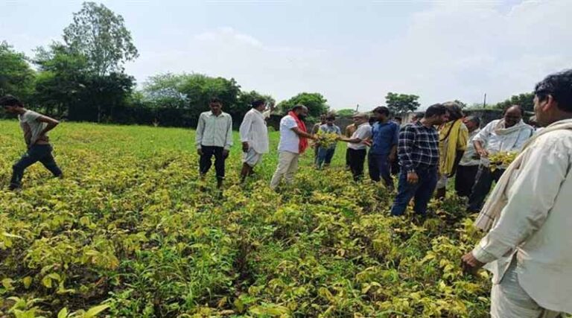
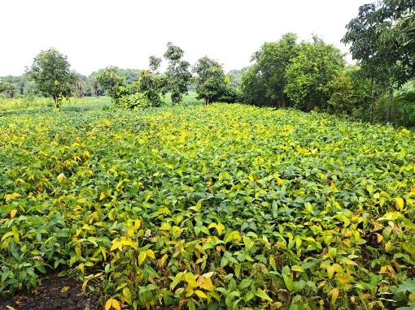
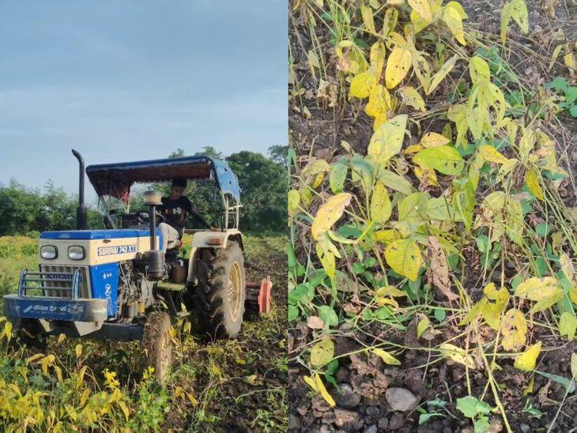
Source: Global Agriculture
Date: 1 September 2025
Location: Mandsaur, Madhya Pradesh

Brief Description
In 2025, a severe outbreak of Yellow Mosaic Virus was reported in soybean crops in Mandsaur, Madhya Pradesh. The disease affected crop health and productivity and raised concerns about yield losses among soybean farmers.

Root Cause
The document identifies viral infection and vector-mediated spread as the root cause.

Effect on Crops
- Yellow mosaic symptoms
- Poor crop health
- Reduced productivity

Effect on Farmers
Farmers faced reduced yield and financial losses.

Government Action
Crop surveys were initiated to assess the extent of damage and support compensation assessment for affected farmers.

Was the Problem Resolved?
No. The report indicates that the outbreak remained an agricultural concern
News Link: https://www.global-agriculture.com/india-region/yellow-mosaic-virus-hits-soybean-crop-in-madhya-pradesh-survey-initiated-for-farmer-compensation/?utm

2024 – Punjab – Yellow Rust Disease in Wheat
Source: Directorate of Plant Protection, Quarantine & Storage, Government of India
Location: Rupnagar, Punjab
Crop: Wheat
Disease: Yellow Rust

Brief Description
Yellow rust was detected in wheat fields in Rupnagar district of Punjab. The disease is important because, if it is not identified and managed at an early stage, it can spread to other areas and cause serious damage to wheat crops. The Crop Protection Centre at Jalandhar detected the initial occurrence and alerted agriculture authorities and farmers.
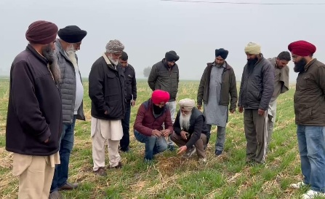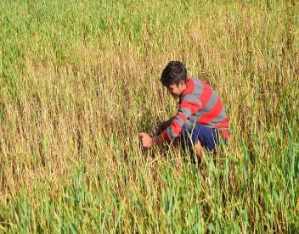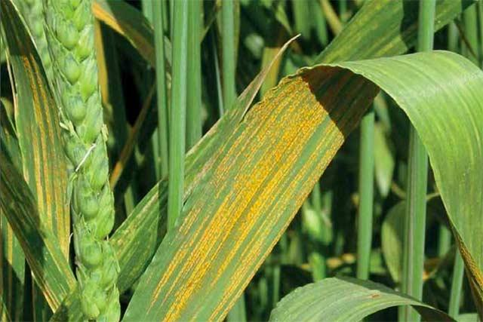

Root Cause
The disease is caused by the fungal pathogen Puccinia striiformis f. sp. tritici. Environmental conditions such as suitable temperature and moisture favour disease development and spread.

Effect on Crops
- Yellow rust lesions on wheat leaves
- Reduced photosynthetic activity
- Poor crop development
- Potential reduction in grain yield

Effect on Farmers
Farmers can suffer yield and economic losses if the disease spreads extensively. Late detection can also increase the cost and difficulty of disease management.

Government/Scientific Action
The Directorate of Plant Protection, Quarantine & Storage reported that the Crop Protection Centre at Jalandhar detected the disease and immediately alerted state agriculture authorities and farmers. Farmers were educated about the importance of early detection, proper crop-management practices and timely fungicide application.

Was the Problem Resolved?
The early detection and immediate advisory helped prevent further spread. This case is particularly useful for your project because it demonstrates how early identification followed by immediate action can reduce crop-disease spread.
News link: https://www.hindustantimes.com/cities/chandigarh-news/pau-warns-farmers-of-yellow-rust-on-wheat-urges-to-monitor-fields-101707503175372.html

2024–25 – India – AI-Based National Pest Surveillance System
Source: Ministry of Agriculture & Farmers Welfare / Press Information Bureau
System: National Pest Surveillance System (NPSS)
Launch: 15 August 2024
Coverage: India
Brief Description
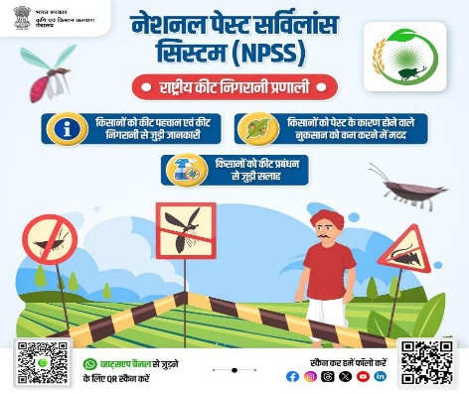
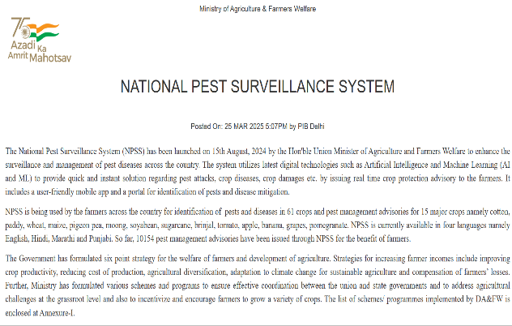
The Government of India launched the National Pest Surveillance System (NPSS) to improve the detection, surveillance and management of crop pests and diseases. The system uses Artificial Intelligence (AI) and Machine Learning (ML) to identify pest attacks and crop diseases and provide crop-protection advisorie s to farmers.

Root Cause
The major challenge is the difficulty of providing fast and accurate pest identification and management advice across large agricultural areas.

Effect on Crops
Delayed detection can result in:
- Pest infestation becoming severe
- Disease spreading to neighbouring crops
- Increased crop damage
- Yield reduction
- Increased pesticide requirement

Effect on Farmers
Farmers may have difficulty identifying pests and diseases at an early stage and deciding what management measure is appropriate. This can result in increased crop losses and unnecessary pesticide expenditure.

Government Action
The Government launched the National Pest Surveillance System (NPSS) using digital technologies such as AI and ML.
The system provides:
- Pest identification
- Disease identification
- Pest surveillance
- Real-time crop-protection advisories
- Digital monitoring of pest incidence
- Management recommendations
The government states that the system can identify pests and diseases in 61 crops and provides pest-management advisories for 15 major crops, including cotton, paddy, wheat, maize and soybean.

Technology Used
AI + Machine Learning + Mobile Application + Web Portal + Pest Surveillance
The system is particularly relevant because the government has explicitly identified timely pest identification and management as its objective.

Was the Problem Resolved?
Partially / Ongoing.
NPSS is an ongoing national surveillance and advisory system rather than a one-time solution. Its purpose is to continuously improve pest identification, surveillance and management.
News Link: https://www.pib.gov.in/PressReleasePage.aspx?PRID=2114896&lang=2&reg=3&utm

Overall Analysis of Crop Pest and Disease Incidents (2017–2025)
The collected news reports from 2017–2025 were analyzed to understand the distribution and occurrence of major crop pest and disease outbreaks in India. The selected cases cover different crops, regions and types of biological threats, highlighting the need for effective crop surveillance and early detection.

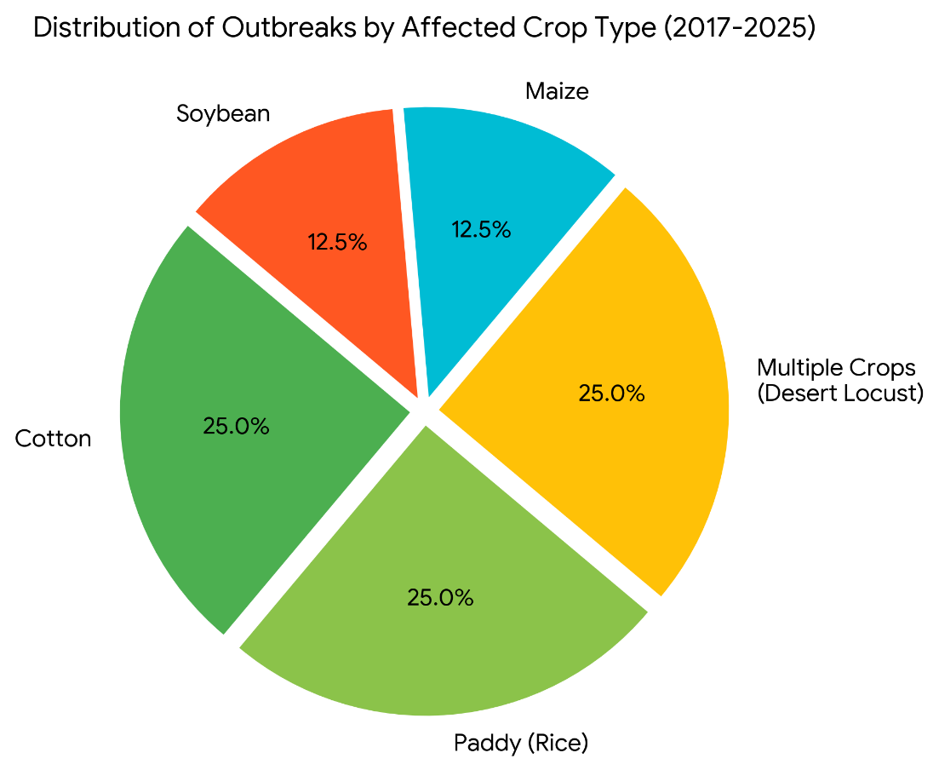
Figure X. Distribution of documented crop pest and disease outbreak cases by affected crop type (2017–2025).

Key Findings from the Analysis
- Cotton – 25%: Pink Bollworm and Green Leafhopper outbreaks.
- Paddy (Rice) – 25%: Paddy Dwarfing/SRBSDV disease incidents.
- Multiple Crops – 25%: Desert Locust outbreaks affecting different crops.
- Maize – 12.5%: Fall Armyworm infestation.
- Soybean – 12.5%: Yellow Mosaic Virus outbreak

Overall observation
The analysis shows that major crops such as cotton and paddy were repeatedly affected by pest and disease outbreaks, while pests such as desert locusts were capable of affecting multiple crops simultaneously. The documented incidents also demonstrate that environmental conditions, rapid pest multiplication and delayed identification can increase crop damage and farmer losses.

Need for Early Detection and Management
The historical cases demonstrate the importance of detecting crop diseases and pest infestations at an early stage. Continuous field monitoring, identification of symptoms, environmental-condition monitoring and timely intervention can help prevent the spread of pests and diseases and reduce crop losses.

Relevance to Our Proposed Solution
These findings provide the basis for developing an Early Detection and Management System for Crop Diseases and Pest Infestations. The proposed system can focus on early identification, crop and environmental monitoring, pest/disease alerts and timely management recommendations to help farmers take preventive action before severe crop damage occurs.

Early detection → Early warning → Timely management → Reduced crop and farmer losses.

